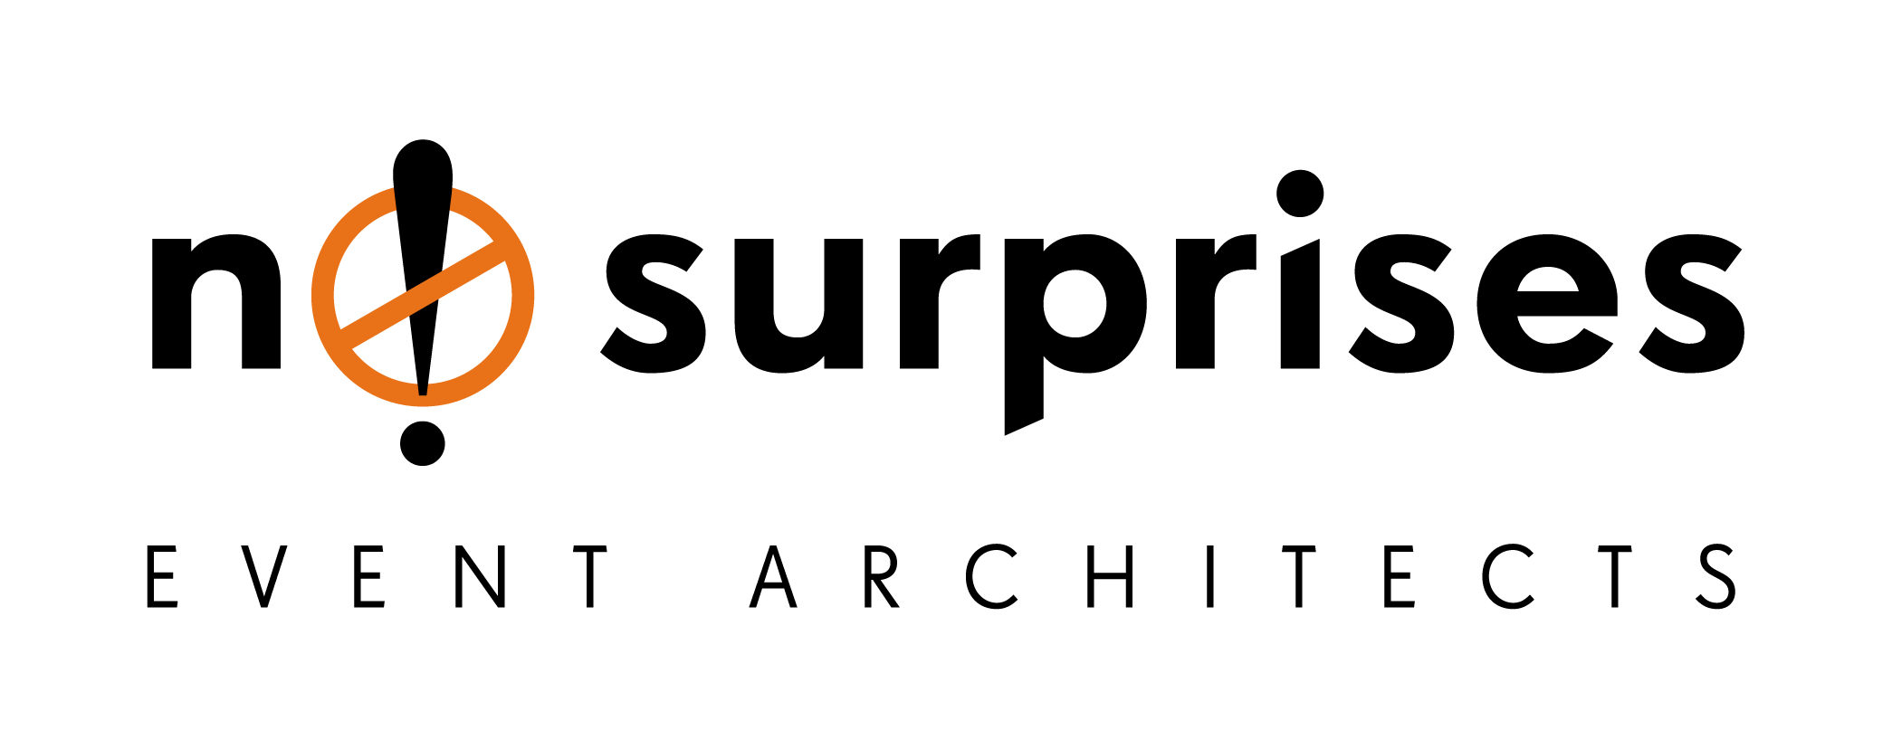

**Now you have a client, what next?**

You got the client, now you need a plan! Here is a step-by-step guide on what to do after being appointed the project manager of an event. We’re always looking for ways to differentiate ourselves from the competition, well here’s a place to start.

**. Briefing** 

**Receive event brief from client; get them to tell you their objectives, the type of experience they want to deliver, what they like (or don’t like!), budget, etc.** A creative brief is an integral part of the client servicing process that may lead to the success or failure of the project produced. Once you receive this, study extensively as it contains information about the client, and explains your client’s requirements for the project. Remember the better the brief, the more accurate the results. Ask a bazillion relevant questions, do your research! (Note that sometimes item 1 and 2 are interchangeable)

**. First Meeting** 

**Schedule meeting with client to discuss event brief and identify stakeholders**. Make sure you fully prepare yourself for the meeting. Obtain the address of the meeting location way in advance, leave early and factor in travel time. Arrive before the agreed time, if you are running late, call/text/email ahead to warn your client! Smile, relax and take notes. Enjoy talking to them and don’t worry about anything. You’ve nothing to lose and everything to gain, so chill!

**. Report**

**Prepare the Contact Report and share with the team and client**. Send the client a written summary after every meeting you have with them. Not only does it confirm your conversation, but it serves as a to-do list, historical record, and a physical reminder that you offer world-class service to those clients and prospects smart enough to hire you. Use the template available to you so you don’t go wrong.

**.  Booking Fee**

**Prepare and issue the “Booking Fee” invoice to the client**. Ensure you receive a form of commitment and security in the bank before you engage your resources in undertaking a project of any nature. Only through such commitments can you focus the full strength of your resources on achieving results for your client. Some clients may be exempted from this fee, for example repeat clients. Please always check with your line manager first.

**.  Concept and Quotation** 

**Create concept design presentation and quotation**. You’re telling a story or presenting a solution to a business challenge. Your client needs to feel like you’ve done your homework, understand all objectives and issues, and are presenting the smartest possible solution. 3D graphics helps them believe something is live, tangible, already there, even when we know it’s only an image on our screen.). Engage in ideation with vendors and provide accurate costing for each item. It’s an opportunity to sell NS again and give the client value for their money.

**. Execute!**

**Let’s get cracking!** Now you need to do what you promised, surpasses their expectations and deliver all objectives world-class style!